**5.**

***a.*** update Employee

set job_code = '501'

where emp_num = '107'

select * from Employee

***b.*** update Employee

set job_code = '500'

where emp_num = '107'

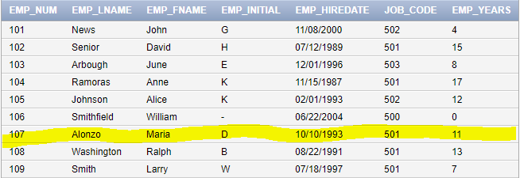

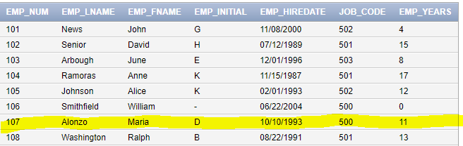

**6.**

***a.*** delete from Employee

where emp_lname = 'Smithfield' and emp_fname = 'William' and emp_hiredate = '06-22-2004'

and job_code = '500'

select * from Employee

(the red arrow is where William Smithfield used to be on the Employee table)

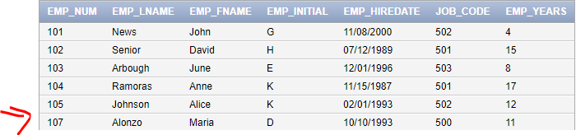

**8.**

***a.*** create table EMP_2 AS

select * from EMP_1;

***b.*** alter table EMP_2

ADD(EMP_PCT NUMBER(4,2))

ADD(PROJ_NUM CHAR(3));

select * from EMP_2

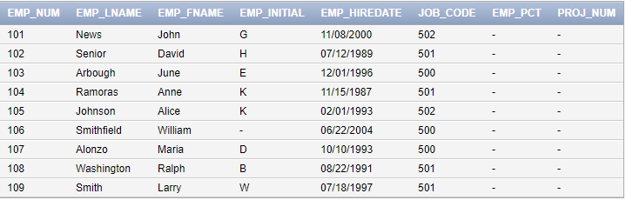

Describe EMP_2

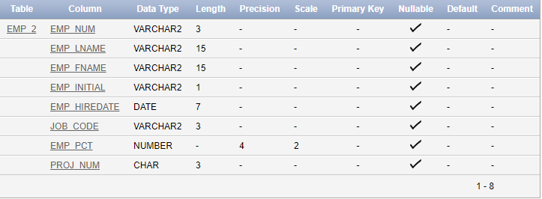

**9.**

***a.*** UPDATE EMP_2

set emp_pct = 3.85

where emp_num = '103'

b. UPDATE EMP_2

set EMP_PCT = 5.00

where emp_num = '101'

UPDATE EMP_2

set emp_pct = 8.00

where emp_num = '102'

UPDATE EMP_2

set emp_pct = 10.00

where emp_num = '104'

UPDATE EMP_2

set emp_pct = 5.00

where emp_num = '105'

UPDATE EMP_2

set emp_pct = 6.20

where emp_num = '106'

UPDATE EMP_2

set emp_pct = 5.15

where emp_num = '107'

UPDATE EMP_2

set emp_pct = 10.00

where emp_num = '108'

UPDATE EMP_2

set emp_pct = 2.00

where emp_num = '109'

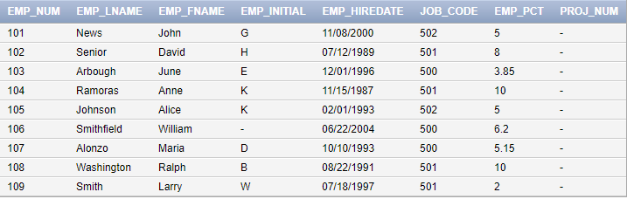

**10.**

***a.*** UPDATE EMP_2

set proj_num = '18'

where job_code = '500'

select * from EMP_2

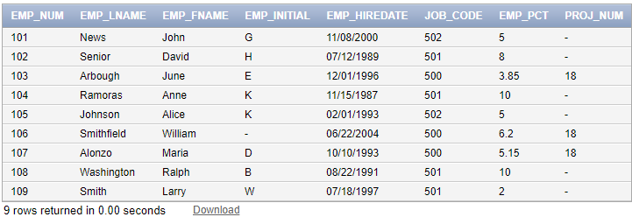

**11.**

***a.*** UPDATE EMP_2

set proj_num = '25'

where job_code >= '502'

select * from EMP_2

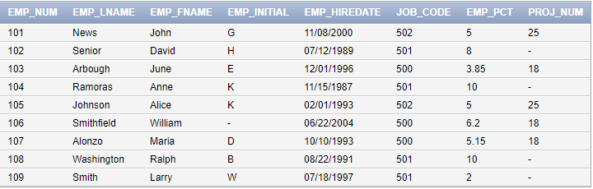

**12.**

***a.*** UPDATE EMP_2

set proj_num = '14'

where emp_hiredate <= '01/01/1994'

and job_code >= '501'

select * from EMP_2

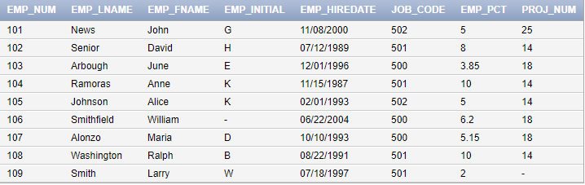

**13.**

***a.*** create table TEMP_1 AS select emp_num, emp_pct from EMP_2;

***b.*** insert into TEMP_1

select emp_num, emp_pct from EMP_2

select * from TEMP_1

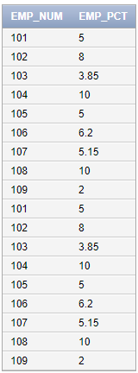

**14.**

***a.*** drop table TEMP_1



**15.**

***a.*** select * from EMP_2

where emp_lname LIKE 'Smith%'

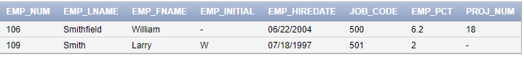

**16.**

***a*.**